Anja Schwobe Final Project - Creative Brief CNMT 210 11/18/2022

**Name & Goals**

Name of website: Origami Inc.

I decided to create a website that will be based on a fictional business named Origami Inc. The main topic of this website is about providing multiple tutorials and information for folding certain origami items.

The goal is to provide information about the practice/artform of origami, and also provide helpful guides/images/etc. To help users learn how to fold certain origami items.

**Target Audience**

The website’s content would particularly be geared towards novice users who need help with learning how to fold a specific origami item. However, the content can also cater to other user scenarios as well:

* Conducting research
* People who are experienced or inexperienced with origami
* Paper crafting interests
* Searching for a new skill to learn or hobby to take on
* Practicing finger dexterity, hand-eye coordination, hand strengthening, fine motor skills, etc.
* Art therapy
* Practiced tradition
* Learning activities
* etc…

**Visuals**

Visuals will include mainly icons to represent functional parts of a website, or images to support site content.

Please note that at this current stage, visuals may not be completely set in stone for use.

Logos/Icons

* Site Logo → Nhor Phai Origami Lineal Color ([www.flaticon.com/free-icons/origami](https://www.flaticon.com/free-icons/origami))
* Search Icon → Freepik Magnifier ([www.flaticon.com/free-icons/search](https://www.flaticon.com/free-icons/search))
* Upload Icon → Ilham Fitrotul Hayat Upload Basic Outline ([www.flaticon.com/free-icons/upload](https://www.flaticon.com/free-icons/upload))

Images/Links

* All-Purpose & General Photos → ([www.pexels.com/search/origami/](https://www.pexels.com/search/origami/))
* Valley Fold + Mountain Fold + Squash Fold ([www.gatheringbeauty.com/blog/2019/8/3-basic-origami-folds-for-beginners](http://www.gatheringbeauty.com/blog/2019/8/3-basic-origami-folds-for-beginners))
* Reverse Folds ([www.origamiway.com/basic-origami-folds.shtml](http://www.origamiway.com/basic-origami-folds.shtml))
* Petal Folds ([origami.me/beginners-guide](https://origami.me/beginners-guide/))
* Rabbit Ear Fold ([origami-resource-center.com/rabbit-ear-fold](https://origami-resource-center.com/rabbit-ear-fold))
* The Boat ([www.thesprucecrafts.com/easy-origami-boat-instructions-4057416](https://www.thesprucecrafts.com/easy-origami-boat-instructions-4057416))
* The Dino ([www.instructables.com/Origami-How-to-Make-a-Dinosaur-1](http://www.instructables.com/Origami-How-to-Make-a-Dinosaur-1))
* The Cat ([www.instructables.com/Origami-Cat-7/](https://www.instructables.com/Origami-Cat-7/))
* The Crane ([origami.me/crane/](https://origami.me/crane/))
* The Frog ([www.itsalwaysautumn.com/origami-jumping-frogs-easy-folding-instructions.html](https://www.itsalwaysautumn.com/origami-jumping-frogs-easy-folding-instructions.html))
* The Box ([www.origami-fun.com/origami-box.html](https://www.origami-fun.com/origami-box.html))
* The Fortune Teller ([scoutlife.org/hobbies-projects/funstuff/166945/how-to-make-a-paper-fortune-teller](https://scoutlife.org/hobbies-projects/funstuff/166945/how-to-make-a-paper-fortune-teller/))
* The Fish ([www.thesprucecrafts.com/traditional-origami-fish-instructions-3953589](http://www.thesprucecrafts.com/traditional-origami-fish-instructions-3953589))
* The Pinwheel ([www.instructables.com/Origami-Transforming-Pinwheel](http://www.instructables.com/Origami-Transforming-Pinwheel))
* The Lucky Star ([www.thesprucecrafts.com/make-origami-lucky-stars-4107161](http://www.thesprucecrafts.com/make-origami-lucky-stars-4107161))

**Color Scheme & Fonts**

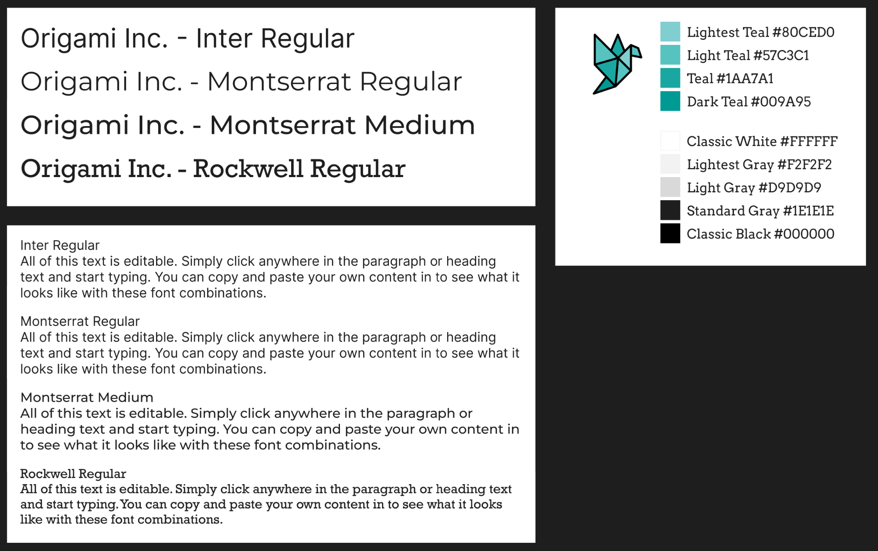

**Sources & Software To Be Used**

* Figma desktop application (<https://www.figma.com/>)
* Visuals (links provided above in Visuals category)
* <https://www.origamispirit.com/2011/01/health-benefits-of-origami/>
* <https://www.fontpair.co/all>
* <https://www.flaticon.com>
* <https://www.lipsum.com/feed/html>